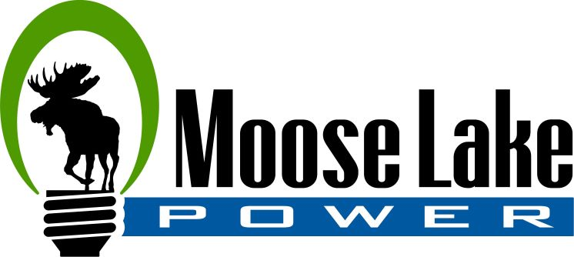

Tree Removal Policy

Trees that come in contact with power lines are a major cause of electrical outages and limbs that touch electric power lines can become energized or even break and fall, bringing the lines down with them.. Timely pruning to maintain adequate clearance between trees and power lines reduces outages, which improves the quality and reliability of electrical service. Safety is another reason to prune trees. Our customers, employees and contractors can be exposed to life threatening risks if limbs touch lines and become energized.
Keeping power lines clear of limbs and brush also provides easier access to our lines, which means quicker restoration of power during storms or other times of trouble.
We have an obligation to maintain our electric facilities to provide safe and reliable electric service, as well as the right to enter and leave private property. We comply with the National Electric Safety Code (NESC) and other rules and regulations that govern the utility industry.
We will only prune or remove trees that pose a potential hazard to our lines. In order to provide safe, reliable electrical service, we maintain the rights of way under our power lines.
Never attempt to trim trees near power lines yourself. Only qualified line clearance workers are allowed to work within a minimum of 10 feet of high voltage lines.
Tree Removal: If you want to remove a tree that has limbs above a pole-to-pole line or hire a contractor to remove it, contact Moose Lake Water & Light (MLWL) at 218-485-4100. We will inspect the line at no charge and determine whether we need to trim or remove the limbs so you can then have the tree safely removed. The homeowner is responsible for the debris removal.
Debris Removal: MLWL cleans up the debris from routine clearance. If there is enough wood, it's cut into manageable pieces. If you don't want the firewood contact MLWL to make arrangements to have the wood picked up. The homeowner is responsible for all other debris removal.
Storm Work: MLWL does not clean up storm-related brush, logs or fallen trees. During storm restoration, MLWL performs a courtesy knock on the door to notify the customer we are on their property. Our immediate priority is to restore power to our customers. We will clear fallen trees and limbs away from company lines and other equipment to ensure public safety, restore service and prevent future power outages. However, all tree limbs and logs are left on site and crews will NOT be returning for clean up.
We will only "top" (remove or cut the top of) a tree if it's necessary to maintain clearance between power lines and the top of the tree required by law. We avoid topping trees if at all possible because:
- Topped trees can regain their original height in as little as two years.
- Fast-growing sprouts spring from a topped tree in large numbers. These sprouts are very susceptible to breakage and storm damage.

Approved August 9, 2010
Coughlin/Kuhlman

