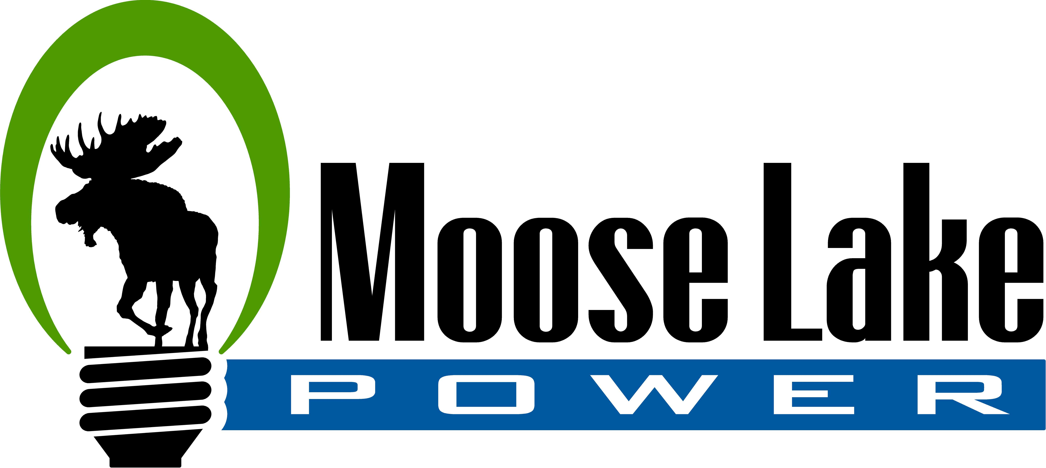

Application for Residential Budget Billing
If approved, budget billing will begin with the September bill

Full Name (Last, First, Middle) __________________________________________________________
(Printed Name Please)

Service Address ______________________________________________________________________

City _________________________________ State __________________ Zip Code _____________

Home Phone ___________________________ Cell Phone ___________________________

Account Number ______________________ Email ________________________________________

To be eligible for budget billing you will need:
- to have been at your current location for a full year
- to have had no late payments within the last year
- to agree to pay the full budget amount every month by the date due
- to agree that any payment less than the budget amount can lead to a service shut-off
- to agree that after a delinquent payment, the account will be removed from budget billing until the following August renewal

Budget accounts will be reviewed and settled in August:
- if your account has a credit balance: that balance will either be used to calculate the next year’s budget (which will lower monthly budget payments), or will be applied to the account in the September billing if you do not wish to continue with budget billing
- if your account has a balance owed: the outstanding budget balance due, along with the current usage, will both be due in September

Moose Lake Water and Light Commission reserves the right to make adjustments to the monthly budget billing amount and will contact the Customer prior to any changes.

X_____________________________________ X________________________________________
Customer Signature Customer Signature

PLEASE RETURN BY SEPTEMBER 15th

FOR OFFICE USE ONLY
Attach Bill History___________ Monthly Amount___________ Approved By__________

