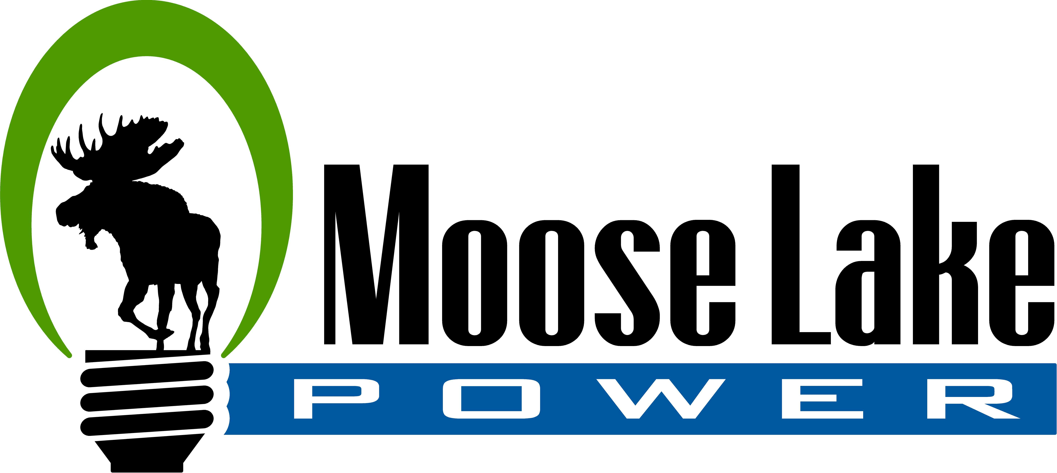
Application for Residential Budget Billing
Full Name (Last, First, Middle) __________________________________________________________
(Printed Name Please)
Service Address ______________________________________________________________________

City _________________________________ State __________________ Zip Code _____________

Home Phone ___________________________ Cell Phone ___________________________

Account Number ______________________ Email ________________________________________

To be eligible for budget billing the customer must:
- Have a 12-month billing history at current place of residence.
- Accounts must be paid in full when enrolling in the program.
- Agree to pay the full budget amount each month by the due date (15th) of customer’s utility bill.
- Agree that budget billing accounts are ineligible for time extensions or payment arrangement to pay budget amount.
- Agree that after two (2) delinquent payments for the current budget year, the account will automatically be removed from budget billing and customer will have to wait 12 months, with a good paying history, before being allowed to enroll in the program again.
  - OR can be placed on autopay
- If a customer is removed from the budget plan, any remaining balance will be due by the next penalty date.
- Customers are encouraged to sign up for automatic payments to avoid late payments.

Budget accounts will be reviewed and settled in August:
- If your account has a credit balance, Moose Lake Power will contact you at the end of the budget year to discuss options for using the credit. If you do not wish to continue with budget billing, the credit will be applied to the account at the end of the budget billing year in September.
- If your account has a balance owed: the outstanding budget balance due, along with the current usage, will both be due in September.

Moose Lake Water and Light Commission reserves the right to adjust the monthly budget billing amount and will contact the Customer prior to any changes.

X____________________________________ X________________________________________
Customer Signature Customer Signature

PLEASE RETURN BY SEPTEMBER 15th
FOR OFFICE USE ONLY
Attach Bill History___________ Monthly Amount___________ Approved By__________

