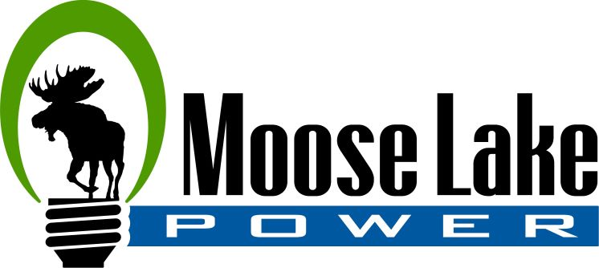

DIRECT PAYMENT

I authorize Moose Lake Power to initiate electronic debit entries to my
______ Checking Account (or) ________ Savings Account
for payment of my utility payment

Customer Name ___________________________________________________________________
Service Address ___________________________________________________________________
Account Number ___________________________________________

Signature _________________________________________________________________________
Date _____________________________________________________

Financial Institution _________________________________________________________________
Financial Institution Routing Number ___________________________________________________
Financial Institution Account Number __________________________________________________
Financial Institution City, State and Zip Code
___________________________________________________
___________________________________________________
___________________________________________________

